Automated Floor Plan Area Verification Using Computer Vision

Overview
Floor area verification is a mandatory step in architectural approval and compliance workflows. Traditionally, this task is performed manually, making it slow, error‑prone, and difficult to scale across large submission volumes.
This article describes a deterministic, production‑ready computer vision system that automatically verifies enclosed floor areas from architectural drawings. The system operates on rasterized CAD/DWF inputs, achieves >99.8% agreement with documented areas, and processes each drawing in under one second on standard hardware.
The solution is designed specifically for regulated environments, where drawing standards, reproducibility, and auditability are more important than heuristic or black‑box approaches.

Architecture Diagrams

High‑Level System Architecture
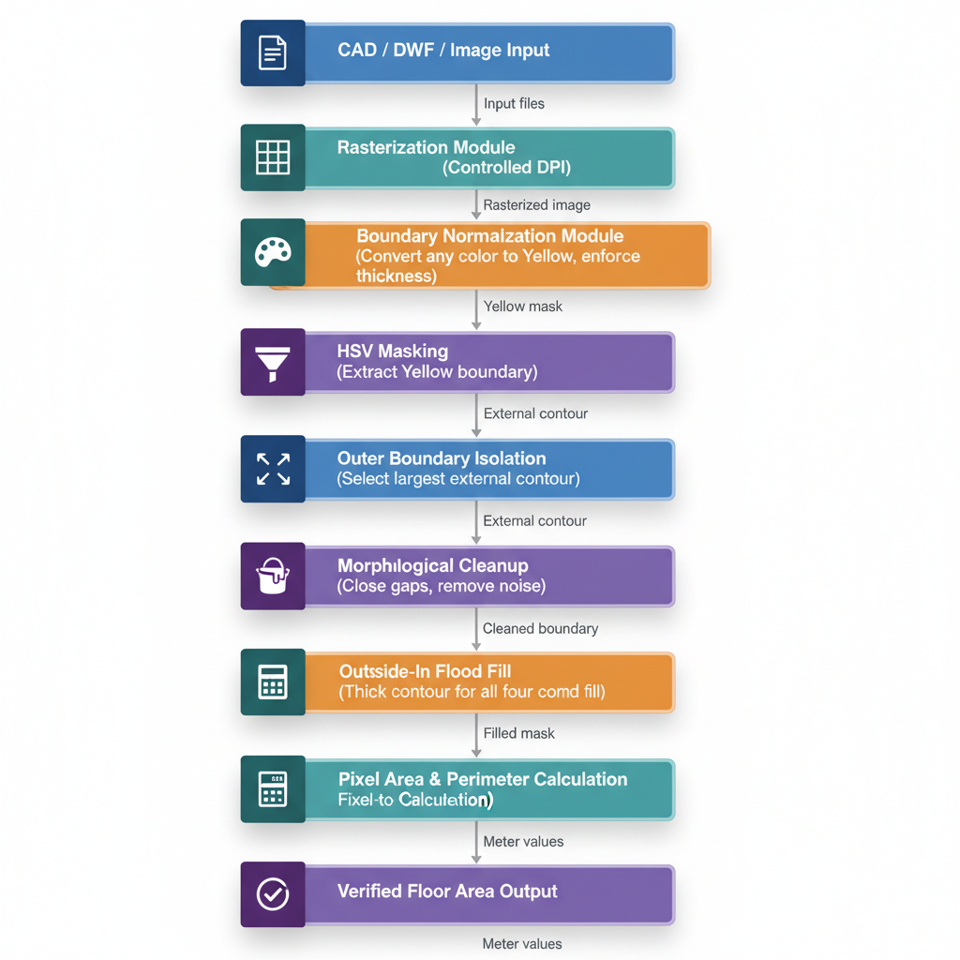

Runtime Processing Sequence
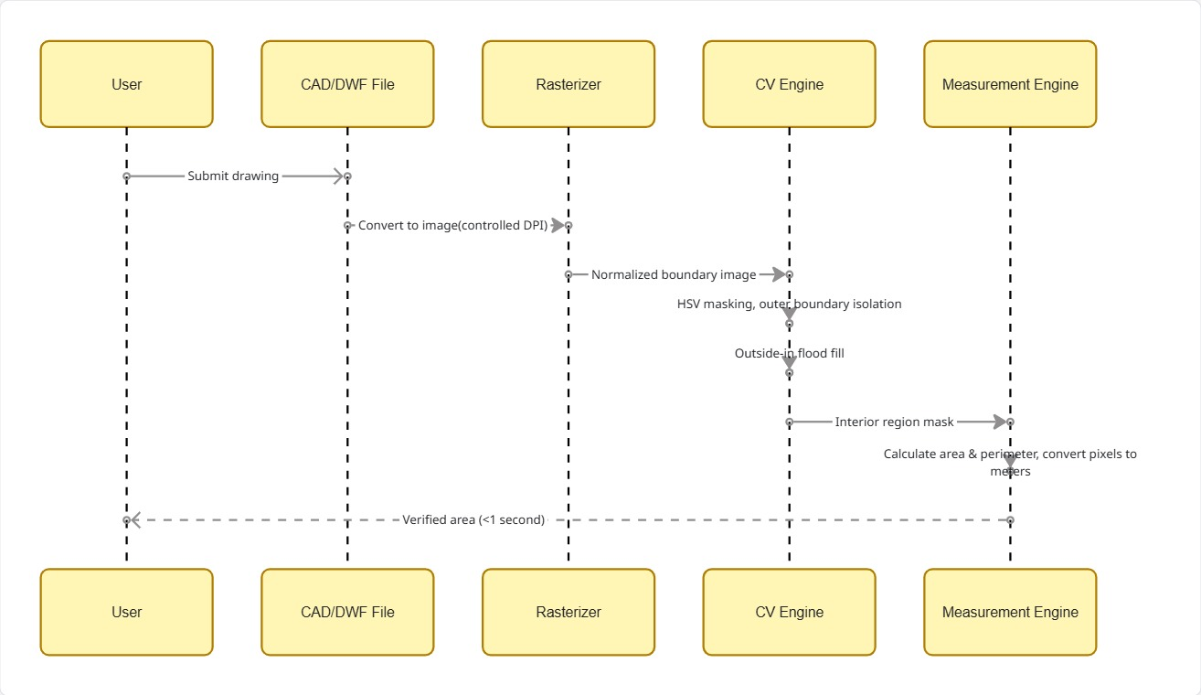

Problem Statement
Approval authorities and compliance teams must verify that the floor area declared in architectural drawings accurately matches the geometry shown in the plan.
Manual verification involves: - Measuring dimensions directly from drawings - Decomposing irregular polygons - Recalculating areas by hand or spreadsheet

Key Challenges
- High time cost per drawing
- Human measurement errors
- Poor scalability for large submission volumes
- Complex layouts with interior walls, annotations, and irregular boundaries

Design Goals
The system was designed to meet the following goals:
- Accuracy: ≥ 99% agreement with documented areas
- Determinism: Identical inputs produce identical outputs
- Explainability: Results can be visually and mathematically audited
- Robustness: Works with interior walls, annotations, and noisy raster data
- Performance: Sub‑second processing time per image
- Integration: Compatible with existing CAD‑based submission workflows

Input Assumptions & Standards
This system operates within a controlled drawing submission environment.

Drawing Rules
- The area to be verified is explicitly delineated in the source CAD/DWF file
- Boundary geometry is defined according to submission standards
- Interior walls, annotations, and dimensions may exist inside the boundary

Rasterization
All drawings originate as vector CAD/DWF files and are rasterized using controlled parameters:
- Fixed DPI (e.g., 96 DPI)
- Known output resolution
- Consistent scaling behavior
This guarantees deterministic pixel‑to‑real‑world conversion.

Boundary Normalization (Preprocessing)
A dedicated preprocessing module converts the designated verification boundary into a standardized raster representation.

What This Module Does
- Detects the boundary geometry defined by CAD rules
- Converts the boundary to a single canonical color (yellow)
- Enforces minimum thickness and continuity

Why This Matters
- Color is not used as a heuristic
- Color acts as a semantic label indicating the verification boundary
- The core algorithm always operates on normalized inputs

System Pipeline
CAD / DWF Drawing
→ Rasterization (controlled DPI)
→ Boundary Normalization
→ HSV Masking
→ Outer Boundary Isolation
→ Morphological Cleanup
→ Outside‑In Flood Fill
→ Interior Region Extraction
→ Area & Perimeter Calculation
→ Pixel‑to‑Meter Conversion
→ Verification Output

Image Processing Methodology

Boundary Detection
- The image is converted to HSV color space
- A fixed HSV range isolates the normalized boundary
Hue: 20–35
Saturation: 100–255
Value: 100–255

Outer Boundary Selection
- Only external contours are considered
- The largest contour by area is selected as the outer boundary
This guarantees that: - Interior walls are ignored - Annotation lines cannot become the boundary

Barrier Construction
The selected outer boundary is converted into a robust flood‑fill barrier:
- The contour is filled to form a solid region
- Morphological closing bridges small raster gaps
- The outline is redrawn as a thick (10‑pixel) barrier
This barrier acts as the only obstacle during flood filling.

Outside‑In Flood‑Fill Strategy

Motivation
Traditional approaches fail when interior walls fragment the interior region. Flood filling from a center seed point often produces holes and incorrect areas.

Strategy
The system instead explicitly identifies the outside region:
- Invert the barrier mask
- Flood fill from all four image corners
- Mark all reachable pixels as outside
- Define the inside as all remaining unfilled pixels

Why This Works
- Interior walls do not block the fill
- Annotation lines are ignored
- Irregular and complex shapes are handled correctly

Interior Region Cleanup
After flood fill:
- Small noise artifacts are removed using morphological opening
- Minor gaps are closed using morphological closing
The result is a single, continuous interior region representing the verified floor area.

Area & Perimeter Calculation

Pixel Geometry
- A contour is extracted from the filled interior region
- Area and perimeter are computed from this contour

Real‑World Conversion
Pixel measurements are converted using a known scale:
Area (m²) = Area (pixels²) / (pixels_per_meter²)
Perimeter (m) = Perimeter (pixels) / pixels_per_meter
Scale is derived from controlled rasterization or calibrated using known dimensions.

Performance
- Processing time: < 1 second per image
- Hardware: Standard single‑core CPU
- No GPU or ML acceleration required
The system is suitable for batch processing large plan submissions.

Validation Results

Accuracy Definition
Accuracy = 1 − |Calculated − Documented| / Documented

Real‑World Test Results
Plan | Documented (m²) | Calculated (m²) | Error (%)
1 | 95.0 | 95.02 | 0.02
2 | 279.0 | 279.0 | 0.00
3 | 372.0 | 372.58 | 0.15
- Mean agreement: >99.8%
- Consistent results across repeated runs

Benefits Over Manual Verification
- Sub‑second processing vs minutes per plan
- Deterministic and reproducible results
- Visual overlays for audit and review
- Robust handling of complex geometries
- Scales easily to hundreds of submissions

Known Assumptions
- Drawings follow predefined submission standards
- The verification boundary is explicitly defined in CAD
- Rasterization parameters are controlled
These assumptions align with regulatory and enterprise workflows.

Future Enhancements
- Automatic scale extraction from CAD annotations
- Batch and parallel processing pipelines
- BIM integration
- Optional ML‑based boundary detection for unconstrained inputs

Conclusion
This system demonstrates that carefully engineered classical computer vision techniques can deliver highly accurate, explainable, and scalable floor area verification for regulated environments.
By combining controlled CAD rasterization, semantic boundary normalization, and an outside‑in flood‑fill strategy, the solution eliminates common failure modes seen in contour‑based methods and manual verification.
The result is a compliance‑grade verification pipeline that is fast, accurate, auditable, and ready for real‑world deployment.

